Dynamics and trends of king scallop (Pecten maximus) fisheries in the English Channel from 2000 to 2015

Eric Foucher¹, Patrick Berthou², Fabienne Daurès², Sébastien Demanèche², and Alain Biseau³

¹IFREMER, Station de Normandie, Avenue du Général de Gaulle, France; ²IFREMER, Centre Bretagne, , France; ³IFREMER, Station de Lorient, France
eric.foucher@ifremer.fr

King scallops (Pecten maximus) fisheries in western Europe were considered an inshore fisheries for some time, only relevant from the UE Member States concerned. Thus, these fisheries are not managed under UE regulations, but only under local regulations. It is clearly the case for French fisheries, which are managed by a mix of national, regional, and local regulations. Some of them have really constraining measures, such the global fishing closure during breeding period for scallops, from the 15th of May to the 1st of October, for all fishermen targeting king scallop all over the French coasts. Technical measures, as the 92mm inside diameter for dredge rings or limitation of number, length and power of boats, complements the French management system. But this management system driven by French laws is not applicable to fishing boats from other UE countries. In UK, apart from the European minimum landing size (11cm in ICES VIId division), no management rules are applied.

On the French side of the Eastern English Channel, this management system works if most of the king scallop fishers were French boats. Recently, opportunistic UK fishing boats coming from Scotland started fishing king scallops in inshore waters, just outside the 12 miles French territorial waters limit at the end of summer (August and September) when the fishing season is still closed for French fishers. Socially, this situation caused and continues to cause conflicts between fishermen and is leading to an overfishing situation.

After reviewing the French management system, the economic dependence on king scallop for the French fishermen based all along the Eastern English Channel coast will be shown. The history of the fishery from 2000 to today, the recent trends of landings (France, UK and Ireland) and effort, the main fishing areas concerned, and the seasonality of the fisheries will be presented, as well as potential solutions proposed for the future.
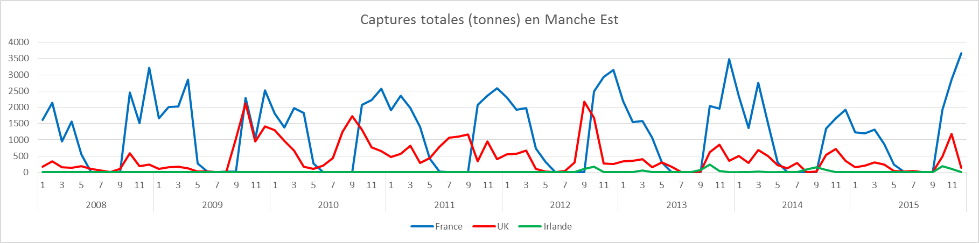
Figure 1: Total landings in the Eastern Channel from 2008 to 2015.

